### Computer Modeling in Earth and Environmental Sciences - Spring 2016

### Simulating the growth, equilibrium, and oscillation of a valley glacier

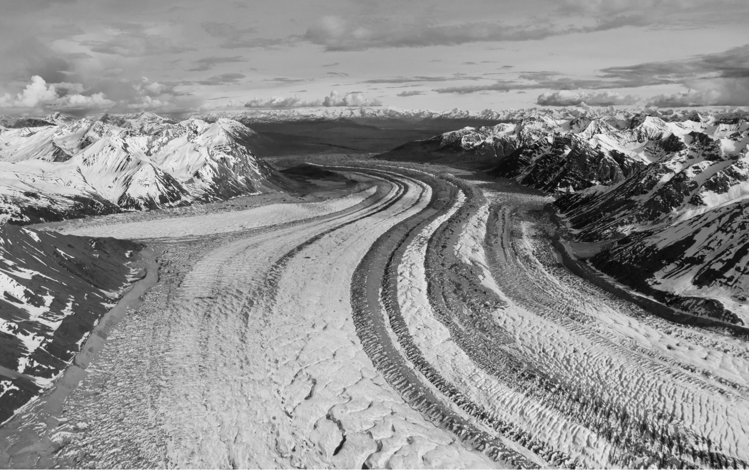

Valley glaciers are powerful geomorphic agents. The thickness of ice in a valley glacier reflects a balance between snow accumulation, melt/sublimation, and the gradient in ice flow. Your task is to create a Matlab or Python model to simulate the growth of a valley glacier in 1D using a prescribed mass balance and a flow law for ice, as discussed in class. Your glacier will form on an initial fluvial valley profile in response to a specified equilibrium-line altitude (ELA) and an altitudinal gradient in net mass balance.

The first step is to simulate the approach to equilibrium starting from an initially ice-free valley.

*What initial surface to use?*

The simplest place to start is with a linear valley longitudinal profile, as discussed in class, and for which there is an analytical solution for the expected steady state terminus position and distribution of ice discharge. Once you have your model working for this initial condition, test whether you can reproduce the analytical solution that predicts a parabolic profile of ice discharge versus distance down-valley, *Q(x).*

# Rules for net accumulation and/or ablation

For obvious reasons, net mass balance (snow minus melt) tends to increase with elevation. The *ELA* is the elevation at which net mass balance is zero. The *ELA* will be one of your parameters. The other is the gradient in net accumulation rate. A typical gradient in net mass balance is 0.01 meters per year per meter of altitude. Often, at high altitudes this gradient levels off at about 1-2 meters per year, so a convenient approach is simply to cap your net accumulation curve at this level for the higher altitudes. (Note: this might not apply to the New Zealand Southern Alps or coastal Alaska where accumulation can be much greater than a couple meters.)

# Mass balance

We will cover this in class. In your numerical solution, the time rate of change of ice volume (and therefore thickness) at each cell will depend on (a) the rate of accumulation or ablation (which depends on altitude), (b) the rate of ice inflow from upstream, and (c) the rate of ice outflow downstream. As in most flow problems (e.g., water, ice, lava, mud/debris), the ice discharge depends on ice thickness; the key difference lies in the flow law.

Here are some things to try with your model:

1. Start with an ice-free surface. Using a fixed *ELA* and mass balance gradient, let ice slowly accumulate and begin to flow until it reaches equilibrium (i.e. achieves a steady ice thickness profile). Plot the ice thickness profile at many different times. Also plot the total ice volume as a function of time. Based on your volume-*vs*-time curve, derive a characteristic time scale for the problem by determining the time it takes to reach (1-(1/e)) of the final ice volume. An equilibrium time scale might be taken to be several (3-4) times this characteristic response time. You might also want to generate a movie of the ice mass on the topography, and/or of the ice thickness profile.

2. How well do you do in reproducing the expected steady state terminus position, calculated according to the procedure presented in class (and written about in the Anderson et al. 2006 paper referenced below)? How well do you do in reproducing the expected steady state ice discharge profile?

3. What happens when the *ELA* oscillates sinusoidally while keeping the mass balance gradient steady at 0.01 (as a crude proxy for glacial-interglacial cycles)? Compare what happens when the period of oscillation is larger than, smaller than, or equal to the equilibrium time scale.

4. What happens if you use the oxygen isotope curve to drive the *ELA* altitude? (Here you will have to scale the 18O) curve to a history of *ELA*, for which choose a full amplitude of *ELA* change to be a few hundred meters).

5. Glaciers are a filter for the imposed climate history, or really the history of annual mass balance, which varies on an annual basis (see Leif Anderson et al. (2014) *Geology* article). Try hitting the model with random noise *ELA* to allow each year’s snowline to vary (*ELA* is really the long term average of the snowline… but what does “long term” mean?) and see how the glacier terminus changes in response.

6. What happens if you start with a concave-upward fluvial longitudinal valley profile more akin to a fluvial profile? (for example, try z = zmin + [(zmax-zmin) * exp(-x/x*)]).

7. What happens if you add an erosion law to the bed of your glacier that looks like, say, *E = a Un,* where *E* is lowering rate, *U* is sliding velocity, and *a*, and *n* are parameters). A typical maximum erosion rate is on the order of 1 mm/yr. Does this look like the valley profiles in MacGregor et al. 2000, or in Anderson et al. 2006?

**timeline:**

You have two weeks to work on this problem. For next week, February 17, we would like you to be able to show us at least the beginnings of a working glacier code. You might start by setting up your matrices and initial conditions, and running a model without any ice flow – just accumulation or ablation. In this case, you should see a wedge-shaped heap of ice that tapers toward the *ELA*, and has zero thickness below the *ELA*. After time t, the thickness at each cell should be either b times t (where b is the net local accumulation or ablation rate, depending on the sign), or zero where b < 0.

If you can get the ice to flow by next week, that would be wonderful. Once you’ve got those bits working, go ahead and factor in changes in ice thickness due to discharge inputs and outputs.

By Wednesday, February 25, we’d like you to have made it at least through step 3 above.

**reading:**

MacGregor, K.C., Anderson, R.S., Anderson, S.P. and Waddington, E.D., 2000, Numerical simulations of longitudinal profile evolution of glacial valleys. *Geology* 28 (11) 1031-1034.

Anderson, R.S., P. Molnar, and M.A. Kessler, 2006, Features of glacial valley profiles simply explained, *J. Geophys Res.*, 111, F01004, doi:10.1029/2005JF000344.

Anderson, L., Roe, G. and Anderson, R.S., 2014, The effects of interannual climate variability on the moraine record. *Geology* 42(1): 55-58, doi:10.1130/G34791.1

Anderson, R.S., *The Little Book of Geomorphology*, Glacier chapter. Go to: http://instaar.colorado.edu/~andersrs/publications.html#littlebook